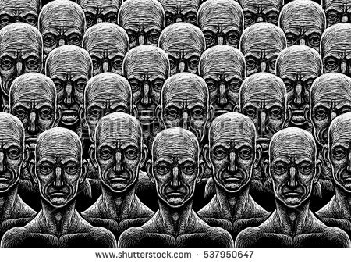**MATERIAL 2**

**Difference Between Utopia and Dystopia**

“Utopia” and “dystopia” are two sides of the same coin. They picture a science fiction setting of two extreme points. Literature also explains the two in a more profound way. But by definition, “utopia” is a society or community setting wherein the people experience the ideal and most perfect life possible. By contrast, “dystopia” highlights the complete opposite, which is a place of extremely unpleasant living and working conditions for most people. Most or all of the societal and governmental systems are bad.

“Utopia” is what many would think as a paradise. The term was first coined by Thomas Moore in his official publication entitled “Utopia” back in 1516. In his utopia, he described an imaginary and solitary island where everything seems to be running smoothly. It’s like looking at blue skies, warm and bright sunlight, working in clean, spacious buildings, living with friendly individuals, going to work happily, and harmoniously coexisting with everyone.

However, there’s a reason why many acknowledge a utopia as a pure work of fiction. It is because the idea of utopia itself seems to be impossible. A real, material world of perfection cannot truly exist. As a matter of fact, “utopia” is translated literally as an imaginary good place that does not physically exist. This kind of world is not just unrealistic but also impractical.

By contrast, a dystopian world, also known as anti-utopia or kakotopia, is totally rundown. “Dystopia” was also coined at the same time as “utopia.” However, its usage became known only in the late 19th century. In a dystopian world, the skies are dull. The sun may not be shining, and the buildings are mostly in ruins. The people (if there are any left) are annoying and unfriendly. Going to work is always a painful experience, and everyone seems not to have settled their differences yet. A dystopian world is like the setting of the popular film “I Am Legend” wherein the main protagonist (Will Smith) appeared to be the only survivor of a ruined civilization.

In several publications, the dystopian setting is also guised as somewhat similar to a utopian society. It’s just that upon further immersion into that society, you’ll eventually learn that there’s excessive control, repression, and abuse. This description practically fits into the idea of police states where great power is used to control the citizens. In this connection, the people holding power become far more advanced and progressive than the rest, which also emphasizes the distinct separation of different classes or castes (i.e. the upper, middle, and lower classes).

Source: <http://www.differencebetween.net/language/words-language/difference-between-utopia-and-dystopia/>